Functional Specification – Cash Flow

Report

Export-Import Bank of Thailand

|  |  |
| --- | --- |
| Project Code: | <EXPJ.B.PJ.TH.EXIMTH*CBS_IMP.CC> |
| Reference: | <Client BZ Reference and Description> |
| Release: | 2.2 |
| Status: | Draft for Client Review |
| Date | 8-Aug-23 |

Contents

Introduction 4

Functional Summary 6

Functional Specification 6

1. 1. ENT-FS02 – Cash Flow Report 6

1.1. Purpose 6

1.2. Background / Functional Requirements 6

1.3. Supported Sample Transaction and Case from Customer 7

1.4. Menu Modification 9

1.5. Screen Layout and Data Sheet 10

1.6. Business Rule / Business Logic 10

1.7. To-be Processing 11

1.8. File /API Layout and Data Sheet 13

1.9. Report Layout and Data Sheet 14

1.10. Additional Impacts 19

Document Acceptance & Release Notice

This is a managed document. Changes will only be issued as a complete replacement document covered by a release notice. All replaced documents shall be destroyed immediately and copies of any obsolete forms destroyed. This document has not been released for use until authorized by the Manager/Project Manager.

This is release **2.2** of the document.

|  |  |  |  |
| --- | --- | --- | --- |
| Reviewed & Approved |  | Date |  |
|  | | | |
| Accepted |  | Date |  |
|  | |  |  |
| Authorized |  | Date |  |
|  | | | |

Build Status

|  |  |  |  |  |
| --- | --- | --- | --- | --- |
| Release | Date of Release | Prepared by | Reviewed by | Comments |
| 1.0 | 11-June-2023 | Emy Bartolome | Marites Magsajo |  |
| 1.1 | 11-July-2023 | Emy Bartolome | Steven Wee  Phen Encarnacion |  |
| 1.2 | 16-July-2023 | Emy Bartolome | EXIM Treasury Team | Created Report Layout for Position Movement and Settlement Transaction Report |
| 2.0 | 27-July-2023 | Emy Bartolome | EXIM Treasury & Operations (Lending) Team | Harmonized report layout based on Treasury team requirements |
| 2.1 | 6-Aug-2023 | Emy Bartolome | EXIM Treasury & Operations (Lending) Team | Updated section 1.9.1.2 report layout and add points for GFT case on section 1.9.1.4 |
| 2.2 | 8-Aug-2023 | Emy Bartolome | EXIM Treasury Team | Updated section 1.9.1.2 and 1.9.2.2 report layout, 1.9.1.4 data sample + 1.9.1.3 / 1.9.2.3 report data sheet |

# 

# Introduction

CBS Foundation and Enterprise workshop activity was conducted at the Export-Import Bank (EXIM) of Thailand premises which highlighted CBS core features in terms of general usability, reference data set up, cross product services, including Customer, Collateral, Limits and Common Utilities. It also covered main integration points for EXIM CRM/LOS into CBS Customer and Limits modules respectively. Gaps were also identified during this stage, hence Functional Specifications documentation to rectify the gaps are prepared for review and approval by EXIM business users and stakeholders.

Abbreviations

The following list defines the abbreviations used in this document.

|  |  |
| --- | --- |
| EXIM | Export Import Bank of Thailand |
| TOR | Terms of Reference |
| AS/400 | EXIM Core Legacy System |
| LOS | EXIM Loans Origination System |
| CRM | EXIM Customer Relations Module |
| SSI | Silverlake Symmetri |
| CBS | Silverlake Symmetri Core Banking System |
| CSD | CBS Common Static Data Module |
| ENT | CBS Enterprise Modules |
| MCL | CBS Customer Module |
| LMT | CBS Limits Module |
| BPM | CBS Business Process Management |
| LND | CBS Lending Module |
| DEP | CBS Deposits Module |
| GFT | CBS Global Funds Transfer Module |
| BDS | Branch Delivery System |

References

|  |  |
| --- | --- |
| ID | Title/Summary |
| G-12 | Able to notify the money in advance and connect to the Treasury Management System (Kastle Treasury)  สามารถแจ้งใช้เงินล่วงหน้าและเชื่อมต่อกับ Treasury Management System (KastleTreasury) หรือมีหน้าจอให้ Treasury ค้นหาข้อมูล/เรียกรายงานเพื่อวางแผนการเงินได้ เช่น Negotiating Bank แจ้ง Claim Reimbursement Value ล่วงหน้า ซึ่งทางส่วนงานต้องแจ้งการขอใช้เงินให้ทางฝ่ายบริหารเงินทราบ |
| G-13 | When exchange rate Transaction, the system must be able to provide a Key-in to reserve the balance in the system. and shows the amount that has been reserved  เมื่อมีการทำธุรกรรมที่เกี่ยวข้องกับอัตราแลกเปลี่ยนระบบจะต้องสามารถให้ Key-in จองยอดเงินในระบบได้ และแสดงให้เห็นวงเงินที่ถูกจอง และมูลค่าวงเงินจะ Update เมื่อมีการ Verify รายการเข้าบัญชี รวมถึงมีการแจ้งเตือนล่วงหน้าให้ทีม Treasury |
| G-14 | When exchange rates transactions generate, the system must be able to display balance information and position details for all segments such as packing credit, import, export.  เมื่อมีการทำธุรกรรมที่เกี่ยวข้องกับอัตราแลกเปลี่ยนระบบจะต้องสามารถให้แสดงข้อมูลยอดเงินและรายละเอียดเกี่ยวกับการ Position เช่น สรุปยอดเงินที่กำลังจะให้กู้ สรุปรายการรับชำระ เป็นต้น สำหรับทุกส่วนงาน เช่น Loan, Packing Credit, Import, Export |

# Functional Summary

This section provides a functionality list of the software product or any modifications on existing Symmetri CBS product.

|  |  |  |
| --- | --- | --- |
| ID | Title/Summary | References |
| FS_EXIMTH_ENT_FS012 | Cash Flow and Interface to Kastle Treasury | TOR |

# Functional Specification

## 1. ENT-FS02 – Cash Flow Report

### Purpose

The purpose of this document is to provide the solution through functional specification resulting from the TOR and Gaps identified during the Product Workshop activity held April 26 to May 16, 2023 at EXIM Bank of Thailand.

วัตถุประสงค์ของเอกสารนี้คือการกำหนดข้อกำหนดการทำงานที่ได้รับมาจาก TOR และ Gap ที่พบระหว่างกิจกรรม Product Workshop ที่จัดขึ้นในวันที่ 26 เมษายนถึง 16 พฤษภาคม พ.ศ. 2566 ณ ธนาคารEXIMแห่งประเทศไทย

### Background / Functional Requirements

CBS is capable of processing foreign currency-based transactions such as cross-border payments, e.g. outgoing or incoming transfers handled in GFT module. Another example are Loan accounts that are booked in foreign currency and needs to be disbursed in local currency, or loan in local currency and needs to be disbursed in foreign-currency. Also repayment transaction in LND where payment is received in local currency to settle or payment for foreign-currency loan need to be monitored. These type of transactions are processed in LND module. Same capability is also expected in Deposits Module for inter-currency transaction, including BDS.

These foreign-currency based transactions are monitored by EXIM Treasury Department via Kastle Treasury system to be able to perform reservation of funds for Treasury FX deals (solution outside of CBS) (TOR G-13). Required data set from CBS modules will need to be interfaced to Kastle Treasury automatically (TOR G-12). These transactions will also generate position and base control accounting entries automatically in the respective modules. Accumulated balance of position control account can be viewed in CBS GL Inquiry system (TOR G-14)

The solution approach in order to support EXIM TOR requirement is to provide facility to monitor CBS module transactions. There will be a provision for 2 reports:

* Position Movement Report – Report that contains all nostro-related settlement transactions (both approved and pending approval).
  + Purpose: For Treasury Team to know the position or movement of all funds going to nostro accounts in advance
* Settlement Transaction Report should include all nostro-related settlement foreign and local currency transactions (both approved and pending approval)
  + Purpose: For Treasury Team to know all position or movement (foreign currency and local currency based transactions) for fund-management purpose.

### Supported Sample Transaction and Case from Customer

ธุรกรรมและกรณีตัวอย่างที่รองรับจากลูกค้า

#### Position Movement

Below is an example of current position movement monitoring sheet where expected data set will be sourced from CBS:

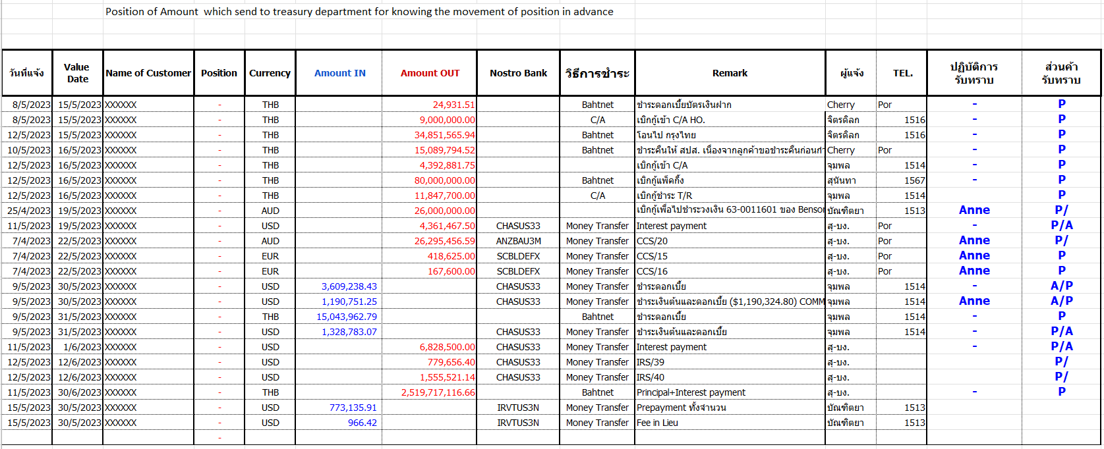

It should also contain additional information:

* Forward Contract – Flag or indicator if a particular transction used forward contract rate
* Module – Source module where settlement was performed
* Remark – Information/Data from settlement screens
* Created By – Maker of the transaction

#### Settlement Transaction Report

This is an example of a schedule for requesting the use of foreign currency money, including department or unit requesting for funds.

This report will be made available in CBS9 and can be generated in an online manner. Details of field-level mapping will be covered in section 1.9.1.

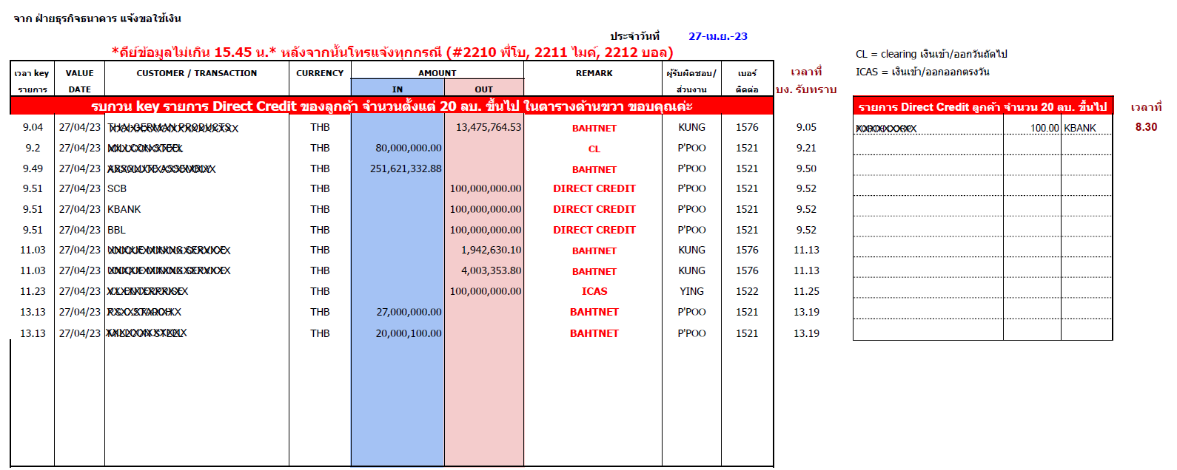

#### Inter-Ccy Transaction

##### Loan Disbursement of Funds after Drawdown

Loan USD1,000,000

Drawdown to Customer in THB

|  |  |  |  |  |  |  |  |
| --- | --- | --- | --- | --- | --- | --- | --- |
| **Account Type** | **Method /GL** | **Amount Type** | **Amount** | **D/C** | **Settle Ccy** | **Exch Rate** | **Converted Amount** |
| I – Internal | Short Term Loan GL | Principal | 1,000,000.00 | Dr | USD |  |  |
| R - Retail | CR - Credit Advice | Principal |  | Cr | THB | 35.00 | 35,000,000.00 |

Above transaction will be processed from Lending Operations applicable for counter/forward contract exchange rate

1. Capture drawdown entries – portion of approved loan will be disbursed
2. Capture drawdown settlement
   1. In the event customer requires to split settlement into different modes, currency and settlement method, system to allow
   2. In the event only one mode of settlement (no split – same currency), system to allow
   3. In the event only one mode of settlement (no split – different currency), system to allow

##### Deposits Module / Branch Delivery System

Foreign-ccy based Transfer Processing & Approval, with or without Forward Contract Deal:

Internal Transfer

Instruction Currency & Amount= USD1,000,000.00

Settlement against Customer Account Currency = THB

Use Forward Contract Rate from Treasury FC deal @34.5523

|  |  |  |  |  |  |
| --- | --- | --- | --- | --- | --- |
| **Account Type** | **DR/CR** | **Amount** | **Settle Ccy** | **Applied rate** | **Converted Amount** |
| R – Retail Deposit | Dr | 35,000,000.00 | THB | 35.00 | 34,552,300.00 |
| I - Internal | Cr | 1,000,000.00 | USD | 1.00 | 1,000,000.00 |

Above transaction will be processed from Branch Operations

1. Capture outgoing transfer with instruction to remit in foreign currency
2. Capture settlement details
3. Capture Forward information
   1. Deal Reference
   2. Use Exchange rate as stated in Forward contract deal

Result of above settlement should generate necessary:

* Accounting Entries
* Credit Advice or SWIFT Message
* Data set will Interface to Kastle Treasury automatically including Forward Contract information

##### Fund Transfer

Outgoing Transfer

Instruction Currency & Amount= USD1,000,000.00

Settlement against Customer Account Currency = THB

Use EXIM Standard Selling Rate @35.00

|  |  |  |  |  |  |
| --- | --- | --- | --- | --- | --- |
| **Account Type** | **DR/CR** | **Amount** | **Settle Ccy** | **Applied rate** | **Converted Amount** |
| R – Retail Deposit | Dr | 35,000,000.00 | THB | 35.00 | 35,000,000.00 |
| N – Nostro | Cr | 1,000,000.00 | USD | 1.00 | 1,000,000.00 |

Above transaction will be processed from Branch Operations

1. Capture outgoing transfer with instruction to remit in foreign currency
2. Capture settlement details

Result of above settlement should generate necessary:

* Accounting Entries
* Credit Advice or SWIFT Message
* Data set will Interface to Kastle Treasury automatically

### Menu Modification

การปรับเปลี่ยนเมนู

Not Applicable

ไม่จําเป็น

### Screen Layout and Data Sheet

เค้าโครงหน้าจอและ data sheet

Not Applicable

ไม่จําเป็น

### Business Rule / Business Logic

#### GL Inquiry UIs

##### Consolidated Information from Inquiry UI

For EXIM Treasury team to be able to know and manage funds, settlement positions for transactions that are processed in CBS9 (Lending, Global Funds Transfer, Deposits), monitoring to be performed thru the use of GL Inquiry screens to monitor processed transactions in CBS:

* Overall Position– will provide currency position for all verified or authorized transactions captured/processed in CBS modules (Lending, Global Funds Transfer, Deposits, General Ledger). All transactions that will hit the position control, including income/expense transfers during end of day run will be included in this view.
* Projected Cash Flow – Nostro Balance – will provide consolidated nostro account balances at branch and currency level
* Projected Overall Cash Flow – will provide cash flow projections based on the transctions processed in CBS. This will include all inflow and outflow of funds irrespective of settlement account type (nostro, retail or internal account).

##### Access Privilege to EXIM Treasury

User Role and access privilege with setting to enable access GL Inquiry UIs will be provided to designated or nominated users. This will be handled thru Security adminstration option of CBS9

#### GL Reports

While consolidated data for all transaction movements, including unverified or pending approval transactions can be monitored via reports:

* Position Movement Report – Inflow and outflow of funds considering all types of settlement account which can be Internal, Retail or Nostro settlement
* Settlement Transaction Report – Schedule for requesting use of foreign currency money, including department, branch, unit or profit or cost center requesting for funds.

### To-be Processing

#### Operational Process Flow

Either Foreign-currency based transactions or local based transaction can come from different module’s transaction processing events, with below standard process flow

* Transaction details to be captured into the system
* In case transaction currency <> settlement currency, applicable exchange rate will be applied
* Automated conversion to equivalent amount based on settlement currency to be derived automatically
* System to generated required base control/position entries due to inter-currency transaction
  1. Inflow to Customer, Source is in foreign currency, e.g. Loan Disbursement

Dr Internal GL for Loan (FCY)

Cr Position Control GL (FCY)

Dr Base Control GL (LCY)

Cr Settlement Account (LCY)

* 1. Outflow from Customer, Source is in foreign currency, e.g. Loan Receipt Settlement

Dr Settlement Account (LCY)

Cr Base Control GL (LCY)

Dr Position Control GL (FCY)

Cr Internal GL for Loan (FCY)

#### Operational Processes

##### Loan Operations

CBS Lending Module business events that can accommodate either inter-currency transactions or within local currency where data will be interfaced to Kastle Treasury:

1. Drawdown/Drawdown increase Settlement as the status save a draft and verification, for all staus will be captured
2. Receipt Settlement as the status save a draft and verification and for all staus will be captured also include auto-receipt and auto hunting function.
3. Drawdown Entries in advance or give forward date be included for cashflow inquiry

##### Branch Delivery (BDS)

Branch Delivery system can accommodate inter-currency transactions where data will be interfaced to CBS Deposits module

##### Deposits

Deposits module serves as back-end module processor of BDS. Once data is received from BDS, same will be interfaced to Kastle Treasury:

1. Internal Transfer

2. Fees in foreign currency, settled in local currency

##### Fund Transfer

Global Fund Transfer handles various inter-currency transactions which needs to be interfaced to Kastle Treasury:

1. Incoming Transfer

2. Outgoing Transfer

3. Internal Transfer

#### CBS EOD Batch Process Run for GL Position Account Update

All accounting entries will be posted into the GL account as part of EOD process run. Once successful, GL Account upto date balance as per last EOD batch process for all GL accounts, including position accounts used for inter-currency transaction can be viewed from GL Inquiry UIs as per existing feature of CBS.

Below is sample screenshot of GL Inquiry UI to show current balance of GL Position Control Account:

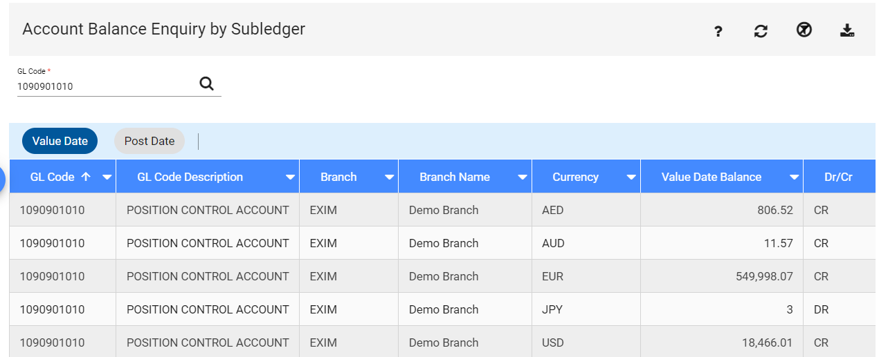

#### Cash Flow Reports

This will be an adhoc report that can be generated online real time that can be used by EXIM Treasury Department to monitor settlement performed in CBS. It is requested this should include **unverified** transactions for cash flow management purpose of EXIM.

Data source of this report will be all financial transactions, including same-currency transactions.

Report/Inquiry can be export to excel file

Report/Inquiry can be provided searching criteria such as:

* + - Business domain (Lending, Global Fund Transfer, Deposits/BDS)
    - Transaction status

#### Access to GL Inquiry UIs

Appropriate business role granted to a system user will allow the user to access relevant GL Inquiry UIs for monitoring cash flow (as mentioned in section 1.6.1.2)

### File /API Layout and Data Sheet

Not Applicable

### 

### Report Layout and Data Sheet

#### Position Movement Report

##### Report Parameter Criteria

| Report Parameter Field | Source/Validations |
| --- | --- |
| Purpose | This is th inter-currency transaction report with data coming from CBS modules |
| Post Date | Transaction Enter Date is the date when transaction is captured in CBS9 |
| Value Date | Transaction Effective Date/Value Date when transaction is to be processed |
| Module | Business module that processed the transaction |
| Nostro Bank | GL Account.Nostro Accounts used by modules |

##### Report Layout

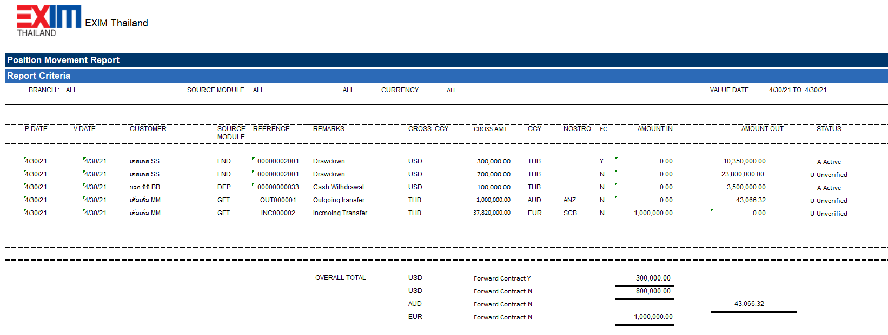

##### Report Data Sheet

| Report Field Name/Attributes | Source/Validations |
| --- | --- |
| Post Date | Transaction.Enter Date or Capture Date |
| Value Date | Transaction.Value Date |
| Customer Code | Client Number |
| Customer Name | XXX COMPANY LIMITED |
| Source Module | Business module where transaction was performed |
| Reference | LND – Loan Number + Drawdown Number  DEP – Account Number  GFT – Reference Number |
| Remarks | Transaction Event Description from the Module |
| Cross Currency | Transaction Currency |
| Cross Amount | Transaction Amount |
| Currency | Settlement Currency |
| Nostro Bank | Client Number of Nostro / Correspondent bank maintained in CBS. This can be null in the event settlement is non-Nostro account type |
| FC | Indicator if Forward Contract was used in transaction |
| Amount In | Incoming Amount. Represents the inflow of foreign currency funds.  This is applicable to Incoming Transfers debiting Nostro account |
| Amount Out | Outgoing Amount. Represents the outflow of funds, may it be foreign or local currency.  This is applicable to:   1. Outgoing Transfers crediting Nostro account 2. Drawdown settlement credit customers local currency account 3. Disbursement during cash withdrawal crediting either customer deposit or internal GL account. |
| Created By | Maker of the transaction |
| Status | Status of the Transaction based on BPM Workflow, or the module’s assignment of transaction which can be any of the following status. :  BPM: If Request is still awaiting verification, status Pending approval to be used  Module - Lending  U – Unverified (transaction still pending authorization)  A – Active (transaction has been authorized)  Module - Payments  I20 – Entered (transaction is still on entered state)  A20 – Processed (transaction has been authorized or in processed state)  Kindly note above only serves as initial information. Complete set of status to consider business processing of modules to be provided during testing stage. |
| Overall Total  Summary of Original Amount | This summary focuses on movement of funds of foreign currencies only.  Overall Total (derived from either Cross amount, or Amount In/Amount Out) as this is intended for foreign currency movements, grouped by:   1. Foreign Currency (Currency from either Cross currency or Currency column as long as ccy <> local ccy) 2. Forward Contract Indicator 3. Amount In – All amounts that resulted to credit to Position Control Account 4. Amount Out – All amounts that resulted to debit to Position Control Account |

##### Report Data Sample Scenarios

In the event there are multi-settlement performed, system should include all settlement details performed on the account, to illustrate how data will be reflected in the report:

1. LND Case of USD1M Loan, Drawdown via Multi Settlement (Disburse in THB with Partial Forward Contract), 1st Settlement – Using FC Deal @34.50, 2nd Settlement – Using Standard Rates @34.00

|  |  |  |  |  |  |  |  |  |  |  |
| --- | --- | --- | --- | --- | --- | --- | --- | --- | --- | --- |
| **Module** | **Account Type** | **Method /GL** | **Amount Type** | **D/C** | **Original**  **Amount** | **Distributed**  **Amount** | **Settle Ccy** | **Exch Rate** | **Forward Contract?** | **Converted Amount** |
| LND | I – Internal | Long Term Loan GL | Principal | Dr | USD 1,000,000.00 |  |  |  |  |  |
| LND | R - Retail | Customer A/C (THB) | Principal | Cr |  | USD 700,000.00 | THB | 34.00 | N | THB 23,800,000.00 |
| LND | R - Retail | Customer A/C (THB) | Principal | Cr |  | USD 300,000.00 | THB | 34.50 | Y | THB 10,350,000.00 |

Position Movement Report will show 2 records, including loan currency as original currency:

1st settlement with No Forward Contract

2nd settlement with Forward Contract

1. DEP Case from USD Deposit Account, Withdrawal in THB @35.00

|  |  |  |  |  |  |  |  |  |  |  |
| --- | --- | --- | --- | --- | --- | --- | --- | --- | --- | --- |
| **Module** | **Account Type** | **Method /GL** | **Amount Type** | **D/C** | **Original**  **Amount** | **Distributed**  **Amount** | **Settle Ccy** | **Exch Rate** | **Forward Contract?** | **Converted Amount** |
| DEP |  | Customer A/C (USD) |  | Dr | USD 100,000.00 |  |  |  |  |  |
| DEP |  | Customer A/C (THB) |  | Cr |  | USD 100,000.00 | THB | 35.00 | N | THB 3,500,000.00 |

1. GFT (Global Fund Transfer) Case of Incoming and Outgoing Transfers

|  |  |  |  |  |  |  |  |  |  |
| --- | --- | --- | --- | --- | --- | --- | --- | --- | --- |
| **Module** | **Case** | **Method /GL** | **D/C** | **Original Amount** | **Amount In** | **Amount Out** | **Settle Ccy** | **Exch Rate** | **Forward Contract?** |
| GFT | Outgoing Transfer | Customer A/C | Dr | THB 1,000,000.00 | THB 1,000,000.00 |  |  |  |  |
| GFT | Nostro A/C (ANZ) | Cr |  |  | AUD  43,066.32 | AUD | 23.22001 | N |
| GFT | Incoming Transfer | Nostro | Dr | THB 37,820,000.00 | EUR  1,000,000.00 |  |  |  | N |
| GFT | Customer A/C | Cr |  |  | THB  37,820,000.00 | THB | 37.82 |  |

#### Settlement Transaction Report

##### Report Parameter Criteria

| Report Parameter Field | Source/Validations |
| --- | --- |
| Module | All business module that processed payment or settlement of transaction  1. Internal A/C such as Cashier Cheque,  2. CASA (RB)  3. Nostro |
| Date Range | Date From/To of settlement performed in the system |

##### Report Layout

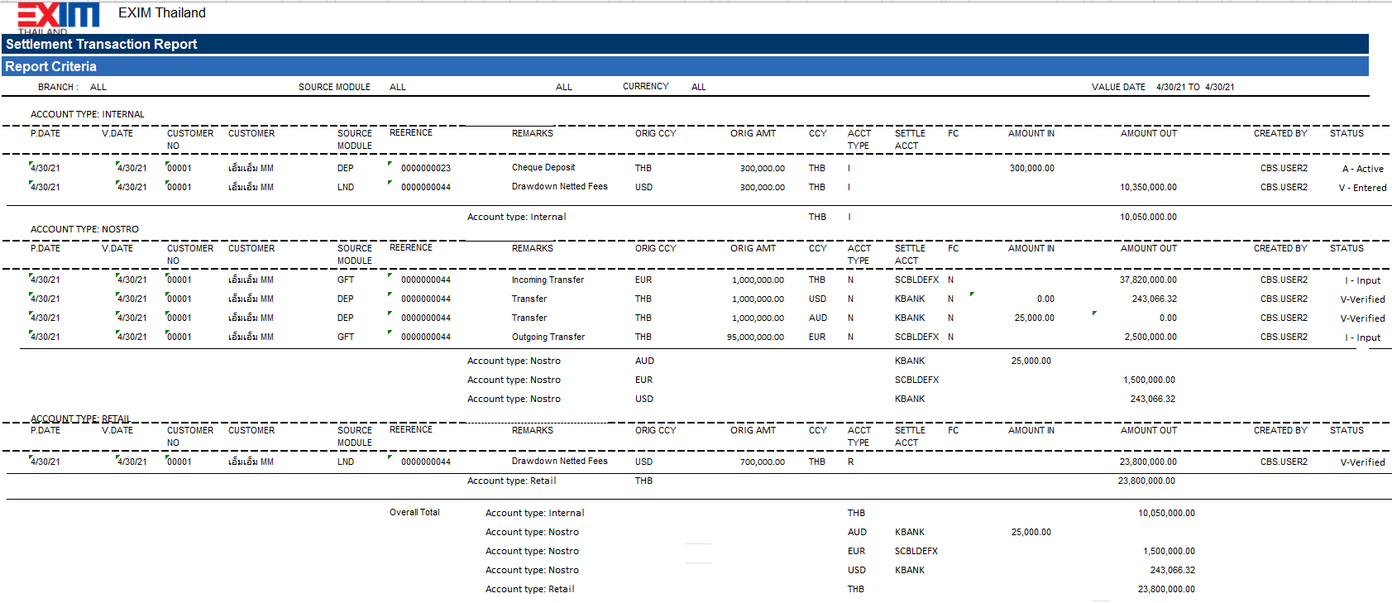

Please also provide the summary by

1. Overall Total by Nostro & CCY
2. Overall Total by Internal Acct type & CCY
3. Overall Total by CASA (RB) & CCY

##### Report Data Sheet

| Report Field Name/Attributes | Source/Validations |
| --- | --- |
| Post Date | Transaction.Enter Date or Capture Date |
| Value Date | Transaction.Value Date |
| Customer Code | Client Number, identified/used by Customer Name |
| Customer Name | XXX COMPANY LIMITED |
| Source Module | Business module that performed the entry |
| Reference | Transaction Reference |
| Remarks | Additonal information |
| Original Ccy | Original or Transaction Currency |
| Original Amount | Original or Transaction Amount |
| Currency | Settlement Currency |
| Nostro Bank | Client Number of Nostro / Correspondent bank maintained in CBS |
| FC | Indicator if Forward Contract was used in transaction |
| Amount In | Incoming Amount from the perspective of settlement account type |
| Amount Out | Outgoing Amount from the perspective of settlement account type |
| Created By | Maker of the transaction |
| Status | Status of the Transaction |

### Additional Impacts

#### System Interface requirement /Integration

Not applicable

#### Migration

Not applicable

#### Fit/Gap Analysis Report

|  |  |  |
| --- | --- | --- |
| ลำดับ | คำอธิบายความต้องการ/ข้อกำหนด | คำอธิบายความต้องการ/ข้อกำหนด |
| G-12 | สามารถแจ้งใช้เงินล่วงหน้าและเชื่อมต่อกับ Treasury Management System (KastleTreasury) หรือมีหน้าจอให้ Treasury ค้นหาข้อมูล/เรียกรายงานเพื่อวางแผนการเงินได้ เช่น Negotiating Bank แจ้ง Claim Reimbursement Value ล่วงหน้า ซึ่งทางส่วนงานต้องแจ้งการขอใช้เงินให้ทางฝ่ายบริหารเงินทราบ | Able to notify the money in advance and connect to the Treasury Management System (KastleTreasury) or have a screen for Treasury to search for information / call for reports for financial planning, for example, Negotiating Bank informs Claim Reimbursement Value in advance, which the department must notify the request for money. Treasury Department informed |
| G-13 | เมื่อมีการทำธุรกรรมที่เกี่ยวข้องกับอัตราแลกเปลี่ยนระบบจะต้องสามารถให้ Key-in จองยอดเงินในระบบได้ และแสดงให้เห็นวงเงินที่ถูกจอง และมูลค่าวงเงินจะ Update เมื่อมีการ Verify รายการเข้าบัญชี รวมถึงมีการแจ้งเตือนล่วงหน้าให้ทีม Treasury | When exchange rate Transaction, the system must be able to provide a Key-in to reserve the balance in the system. and shows the amount that has been reserved And the limit value will be updated when Verify the transaction into the account. Including advance notification to the Treasury team. |
| G-14 | เมื่อมีการทำธุรกรรมที่เกี่ยวข้องกับอัตราแลกเปลี่ยนระบบจะต้องสามารถให้แสดงข้อมูลยอดเงินและรายละเอียดเกี่ยวกับการ Position เช่น สรุปยอดเงินที่กำลังจะให้กู้ สรุปรายการรับชำระ เป็นต้น สำหรับทุกส่วนงาน เช่น Loan, Packing Credit, Import, Export | When exchange rates transactions generate, the system must be able to display balance information and position details for all segments such as packing credit, import, export. |